AREER & COUNSELING CELL REPORT
(2014-15 session programmes )

Report of “Placement Linked Skill Development Training Programme on Voice & Non-Voice BPO & Direct Sales & Retail Marketing” held under Career and Counseling Cell, 2015
Ambedkar College , Fatikroy, Tripura

The Career and Counseling Cell held a programme organised by District Administration, Unakoti District in collaboration with Sarah Jahan Initiative Pvt. Ltd on 26th February 2015 in the Seminar Hall of the college. Both Students and teachers attended the programme. The Objective for organizing the programme is to make the students gather awareness about skill development training programmes. Relevant lectures were delivered by the Resource person in the programme giving more stress on the various placement related Skill Development Programmes made available by the govt. for the benefits and secure future of the students. In the Valedictory session, students clear their queries. The programme ends with thanks to resource persons, students and staffs for their kind support to make the programme grand success.

NO. of Students benefitted: 62
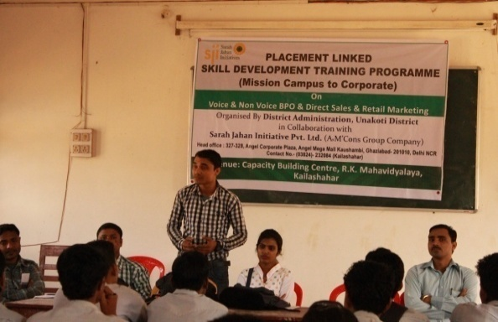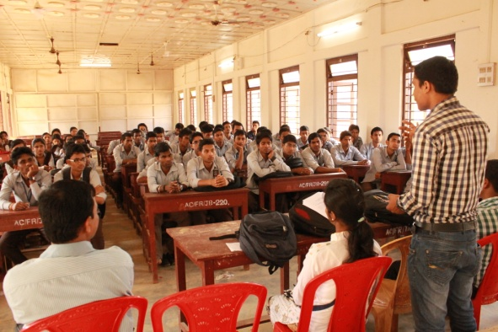

Glimpse of the programme held at Ambedkar College,Fatikroy.

