CAREER & COUNSELING CELL REPORT
(2016-17 session programmes )
Report of an awareness Programme On “Various Educational & Career Scope”
held under Career & Counselling Cell 2016 at Ambedkar college, Fatikroy, unakoti Tripura.
With the collaboration of ICFAI University, an awareness programme on “Various Educational & Career Scope” was held on 17-11-2016.With representatives from ICFAI University; the programme was well attended by students and teachers alike. The main motive of the programme was to introduce to the students the various higher educational programs available at ICFAI University situated at the capital of the state. The representatives from the University gave a comprehensive and relevant knowledge to the students regarding the process, procedures as well as the tentative expenditures for undertaking the courses and also encouraged the students for various educational and career scope at ICFAI University.
Programme Schedule
1.Inaugural Session (10.30 am)
11:00 AM Inauguration by lighting of the holy lamp
Inaugural speech :Mrs Padmashree Majumder, PGT, Ambedkar College.
Presidential address : Dr. Subrata Sharma Principal-In-charge Ambedkar College.
Vote of thanks :Mr Manmahan Debnath.,Coordinator, Career and Counseling Cell
2.Technical Session(11 Am)

i)A formal introduction to the higher educational and diploma programs/courses available at Icfai University,Agartala.
ii)Information regarding the process, procedures and expenditures of the programs/courses.
iii)A brief video of the campus was shown to the students by Mr.S.Ghosh, representative of ICFAI University.
No. of students benefitted: 124
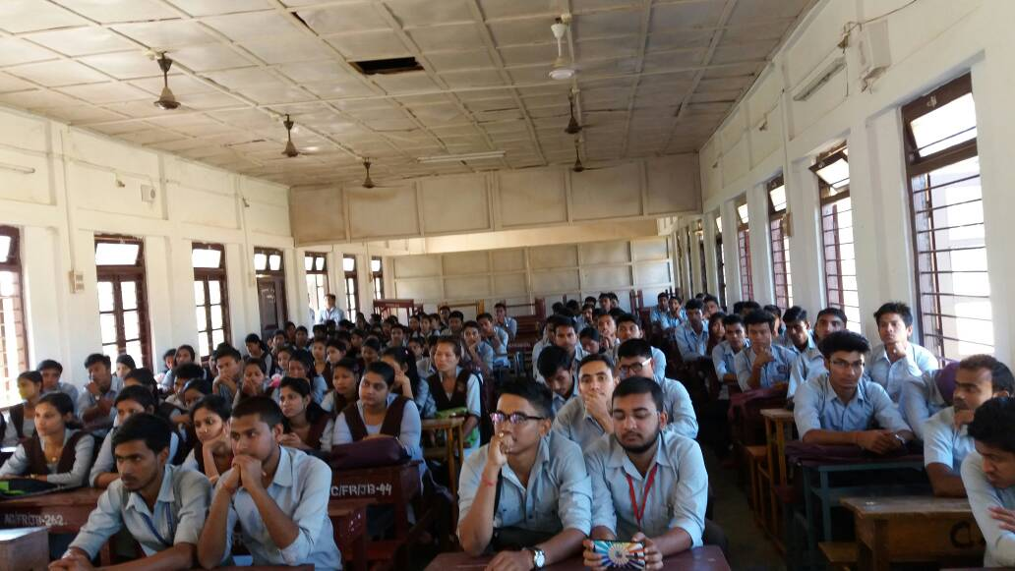

Report of the “Motivational programme on Career guidance” held under Career and Counselling Cell 2017
Ambedkar College, Fatikroy,Unakoti Tripura.
The Career and Counselling cell organized a “Motivational programme on Career guidance” on 04-04-2017 at the Seminar Hall of the college. The objective of the programme was to make the students gather knowledge and awareness about the suitable ways of selecting a career by highlighting the various career scope in both the fields of Humanity and Science. For the student’s easy comprehension and interest, motivational videos of successful UPSC aspirants & rank holders were shown to encourage as well as change the students perspective about competitive exams. The programme was well attended by both students and faculties of the college.
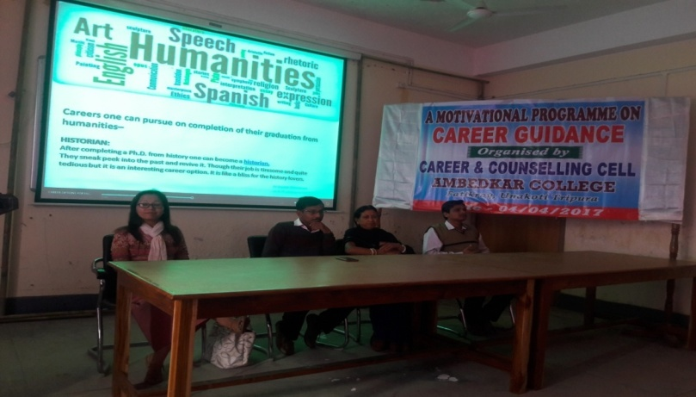

Programme Schedule
1.Inaugural Session (11 am)
11:00 AM Inauguration by lighting of the holy lamp
Inaugural speech :Ms L.Sailo AP, Ambedkar College.
Presidential address : Dr. Subrata Sharma Principal-In-charge Ambedkar College.
Vote of thanks :Mr.Shyamal Biswas, Member , Career and Counseling Cell
2.Technical Session(11:20 Am)

i) Lecture on “ The importance of early planned studies for a successful career” by Ms J.Darlong, AP.
ii) Motivational video clips were shown to the students .

3.Valedictory Session (2Pm) by Ms Jacinta Darlong, Coordinator, Career & Counseling Cell.

No.of students benefitted: 72

