CAREER & COUNSELING CELL REPORT
(2018-19 session programmes )

Report on the programme “ Various Career Scope In Indian Army” held under career and counseling cell 2018
Ambedkar college fatikroy, unakoti , Tripura.

The Career and Counseling Cell of Ambedkar College in collaboration with the 30th Battalion Assam Rifles organized a lecture program on the various career scope in Indian Army on 31st July 2018 at room no 5 , Academic building of the college. The objective of the lecture program was to provide the students the basic and essential knowledge in regards to the various ways or direction of joining the Indian Army. The program was well attended by students and teachers of the college. The program began with a welcome address from Mr Biplab Majumdar, member of Career and Counseling cell ; which was followed by a short speech by Dr Subrota Sharma ,Principal I/C ,Ambedkar College .The resource person of the program was Major Anurag Sharma of 30th Battalion Assam Rifles. Major Anurag Sharma presented his lectures in a slide show on a projection screen for the student’s better understanding and clear idea henceforth grabing their full attention. With a full-fledged description of the various career scope in the army ,he went on to discuss about the several opportunities the Indian Army provides to the young aspirants who desires to join the forces; the essential academic eligibility for both men and women criteria were discussed and lastly, a short lecture on discipline and its role in moulding one’s life encouraged the students in understanding the immense importance of a discipline life for a successful future .At the end of the lecture students were given the opportunity to clear all their doubts and queries . The program ends with a vote of thanks delivered by Mrs.J.Darlong, Co-Ordinator Career and Counseling Cell, Ambedkar college to all the participants of the beneficial program in making it a grand success.
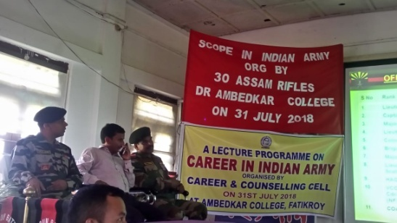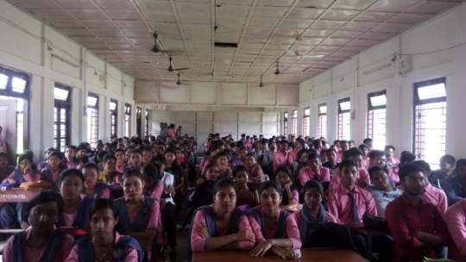

Programme Schedule
1.Inaugural Session (10.30 am)
11:00 AM Inauguration by lighting of the holy lamp
Inaugural speech :Mr Biplab Majumdar, AP, Ambedkar College.
Presidential address : Dr. Subrata Sharma Principal-In-charge Ambedkar College.
Vote of thanks :Mrs Jacinta Darlong, Coordinator, Career and Counseling Cell
2.Technical Session(11 Am)

I)Information regarding the life & functions of the Armed forces by Maj. Anurag Sharma.
ii) Information regarding the various career scope in the Army.
iii) Information about the essential academic eligibility for both men and women criteria were discussed with the use of PPT.

3.Valedictory : Hv. N. Das, Assam Rifles.

No. of students benefitted: 176

Report of “the lecture programme sky is the limit” organised 2019 by career and counseling cell,
Ambedkar college fatikroy unakoti, Tripura.

The Career and Counseling Cell of Ambedkar College organized a lecture program titled “Sky Is The Limit” on 22nd February 2019 at Seminar Hall of the college. The objective of the lecture program was to provide the students the basic and essential knowledge of the limitless job opportunities in various sectors. The program was well attended by students and teachers of the college. The program began with a welcome address from Ms L.Sailo, member of Career and Counseling cell ; which was followed by lectures in a slide show on the projector by screen by Mrs.J.Darlong, Co-Ordinator Career and Counseling Cell ; for the student’s better understanding and clear concept. Discussions on books with great feedback were made and the lecture also include in establishing the concept of online job application explained by Mitu Das, Asst.Prof .The lecture also included explanation on the various manners to make one own’s port folio and the manner to fill in the applications .Through this programme students were made aware about the different issues related to job opportunities such as, how and where to get proper information of the job opportunities in a particular area and how to apply for the same.
At the end of the lecture students were given the opportunity to clear all their doubts and queries . The program ends with a vote of thanks to all the participants of the beneficial program in making it a grand success.
Programme Schedule

1. Inaugural speech :Ms.L.Sailo, AP, Ambedkar College.
2. Brief information on the essential academic eligibility : Mrs. J.Darlong, AP, Ambedkar College
3. The concept of online job application & port folio : Mrs Mitu Das
4. Feedback from Students.
5.Vote of Thanks : Mrs. J.Darlong, coordinator , Career & Counseling.
No. of students benefitted: 64

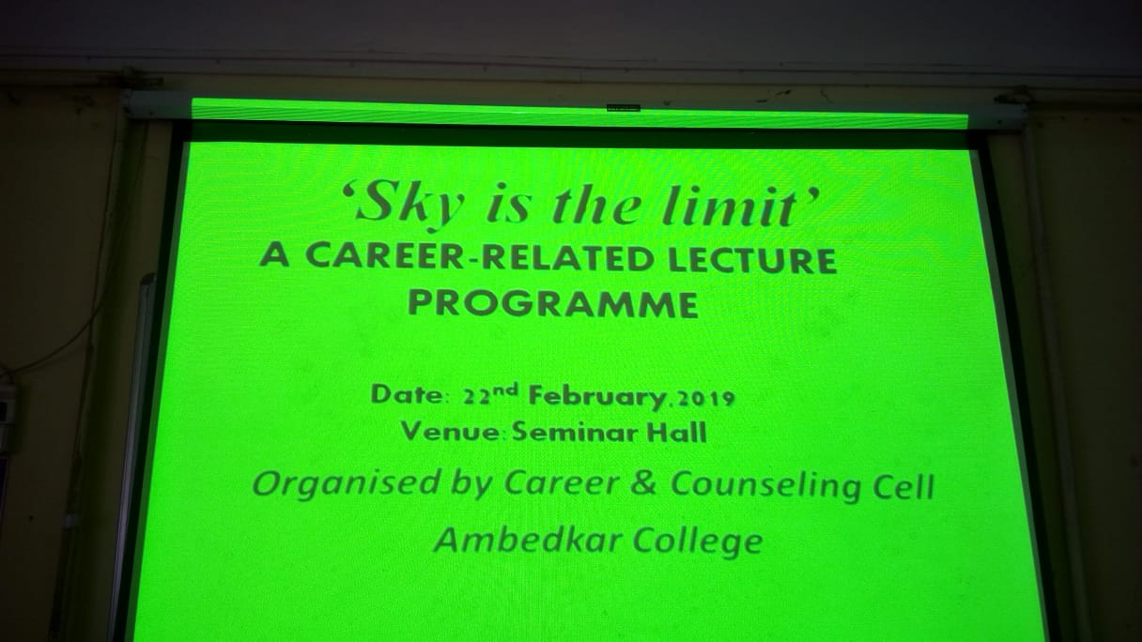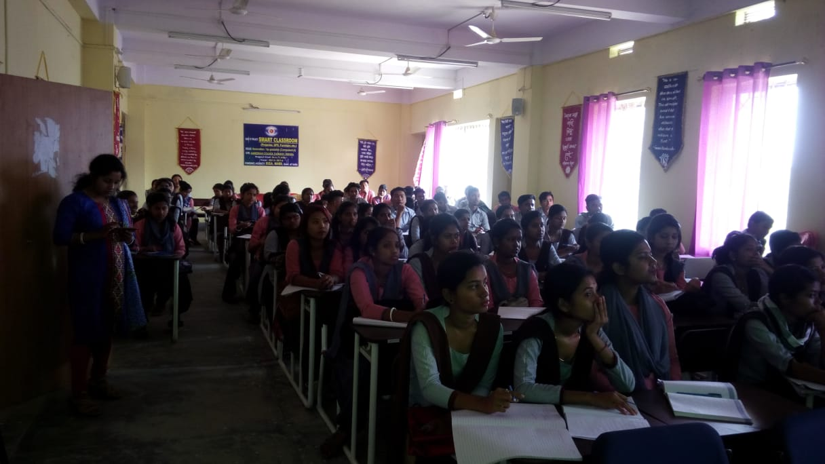S

