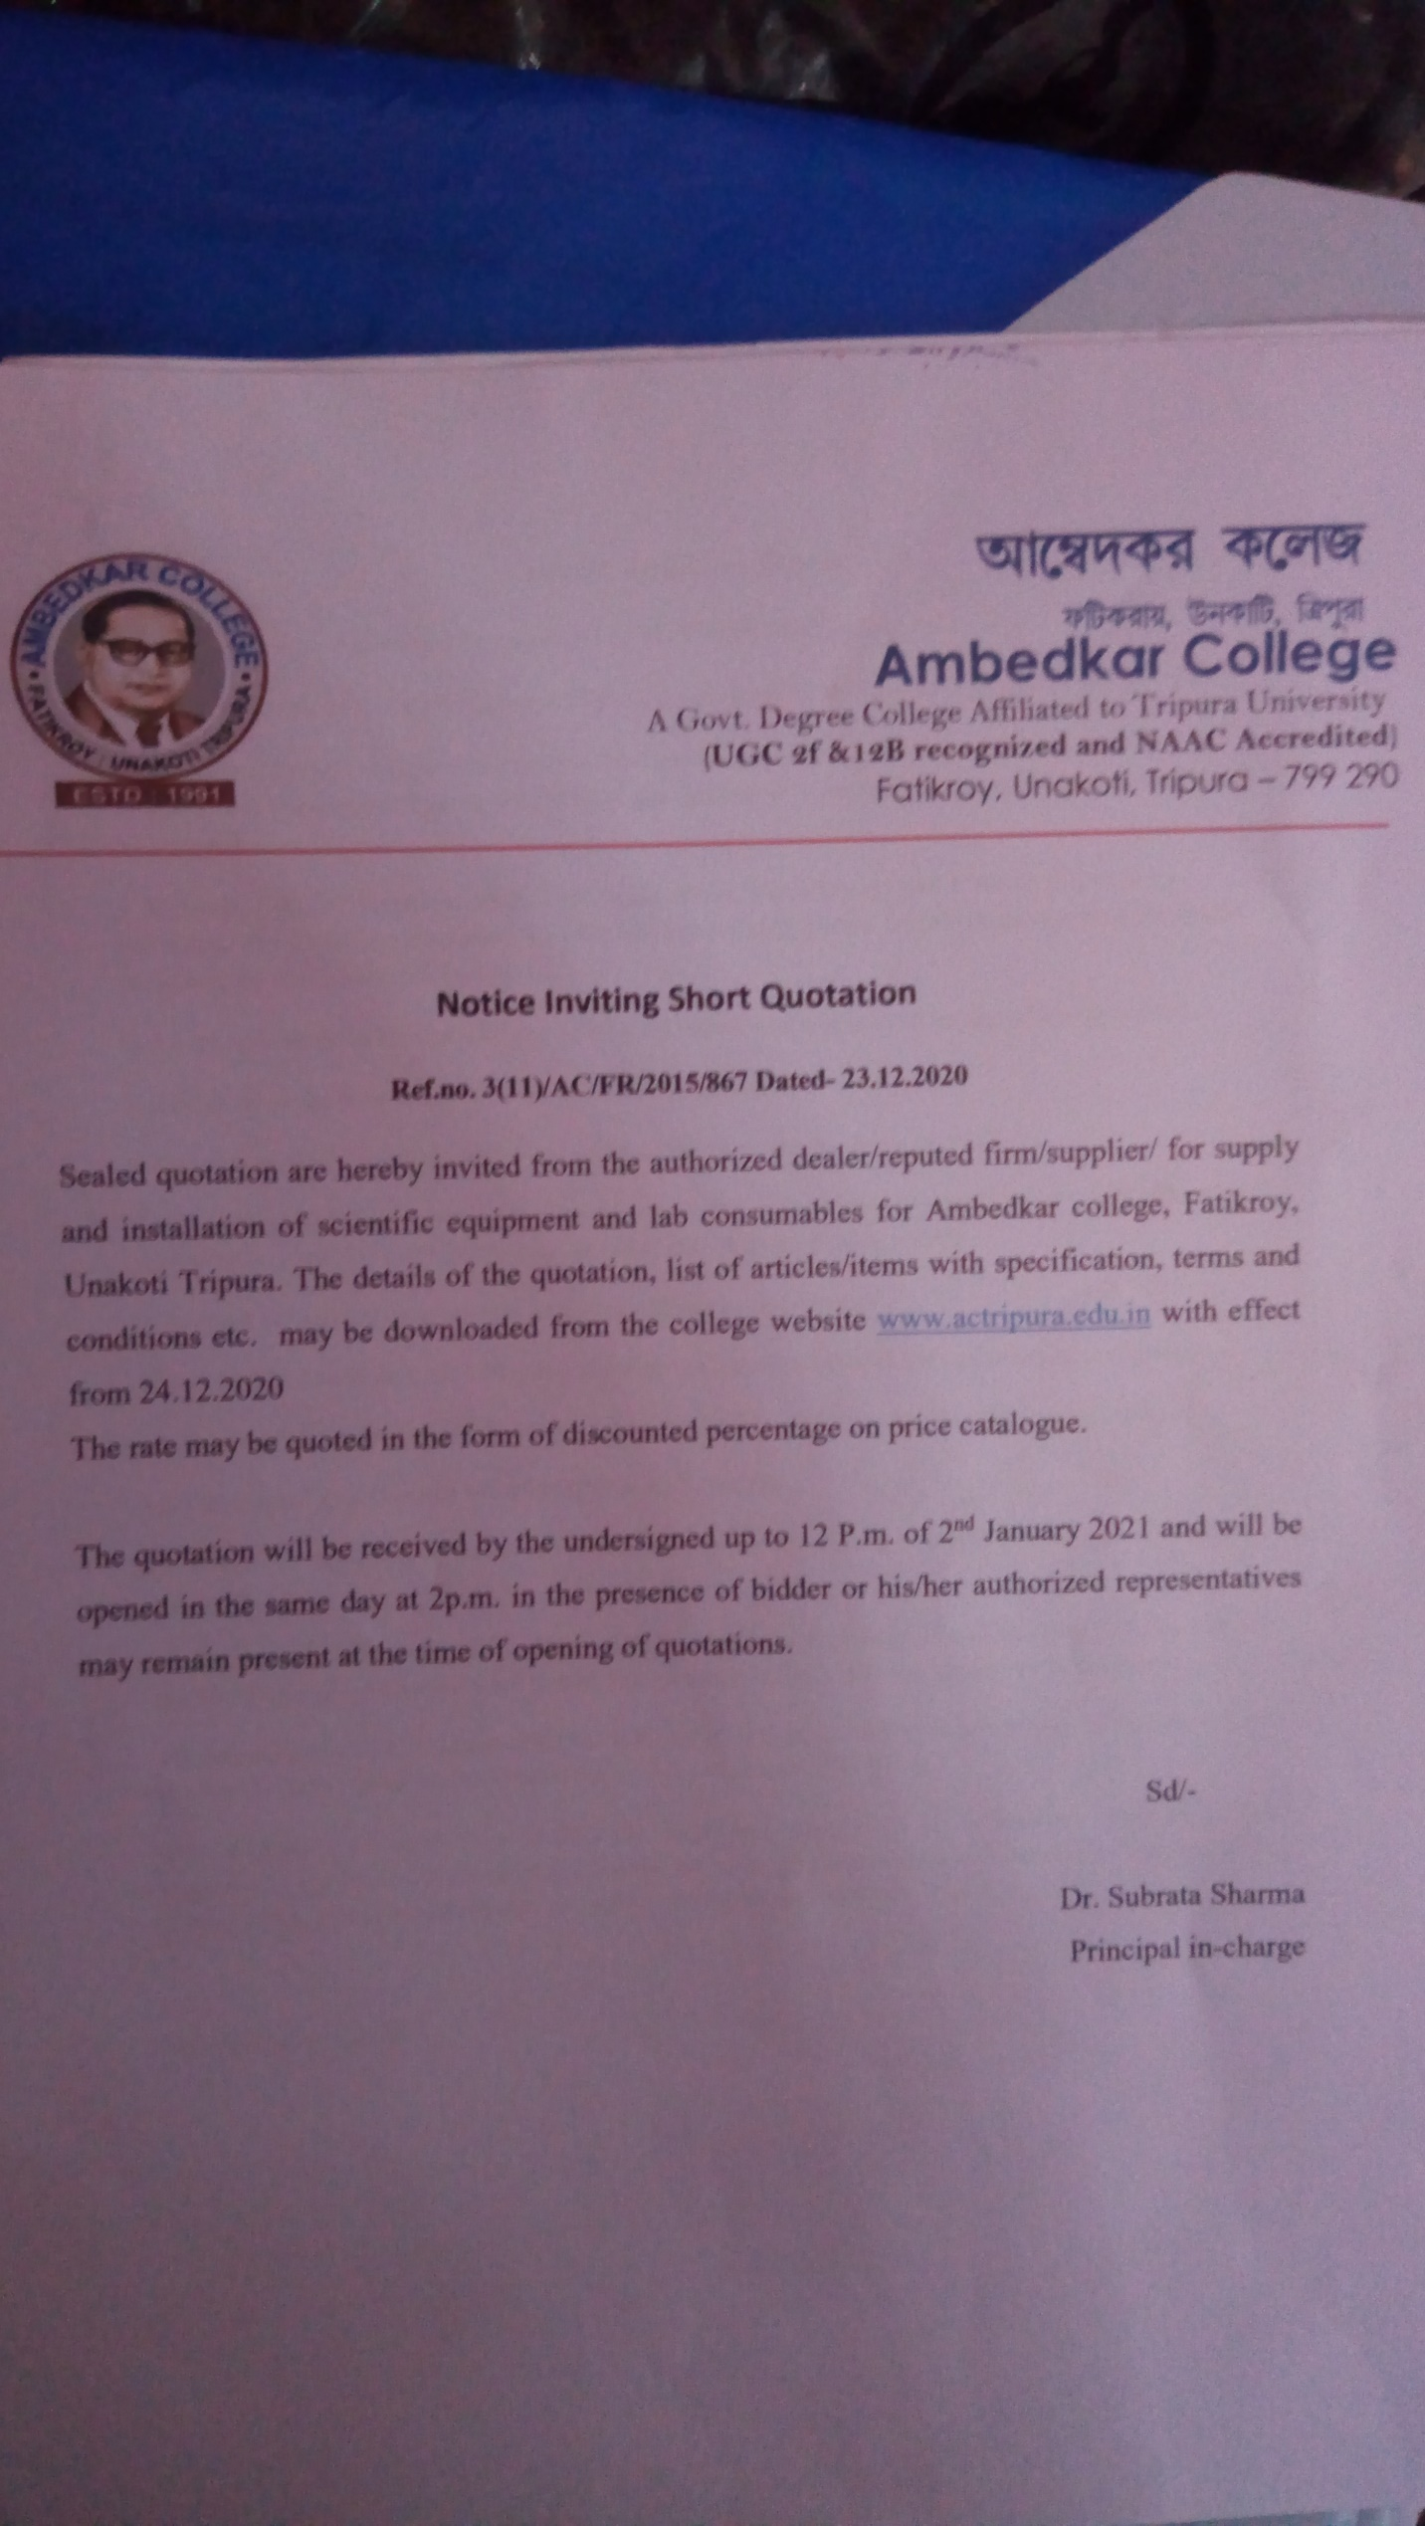
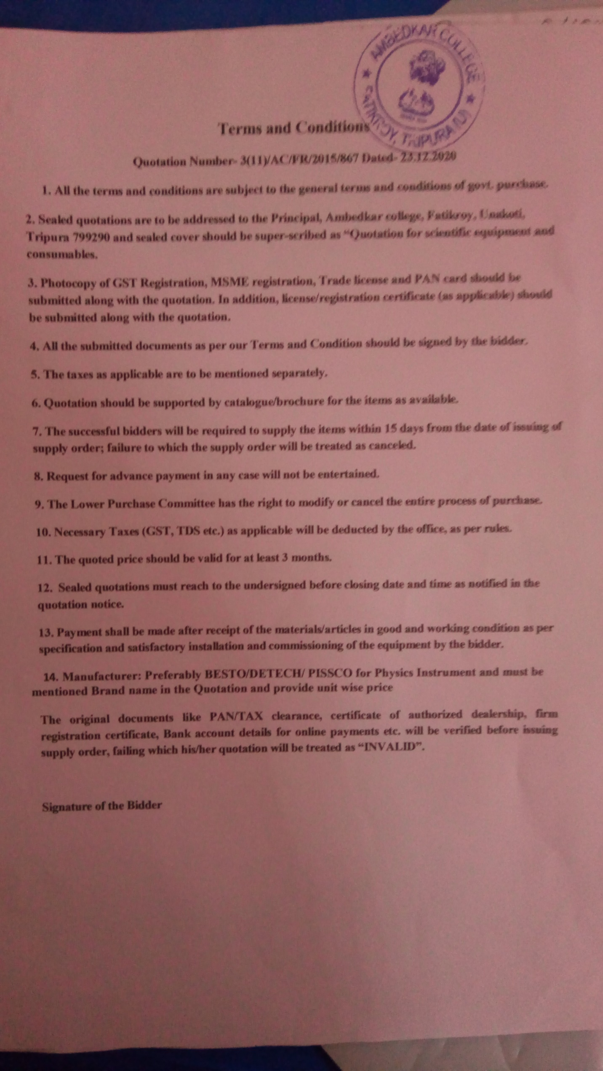
Requisition for Department of Zoology
Sl. No | Name of Items required | Quantity
1. | Manganese Sulfate,(MnSO₄,H₂O/MnSO₄,2H₂O/MnSO₄,4H₂O/MnSO₄,5H₂O | 500 gm
2. | N/80 Sodium thiosulphate Solution | 2Ltr
3. | Dry Sodium thiosulphate(Na₂S₂O₃,5H₂O) | 100gm
4. | Starch | 500gm
5. | Boric Acid | 100gm
6. | Sodium Hydroxide(NaOH) | 500gm
7. | Potassium Iodide | 250gm
8. | Concentrated Sulphuric Acid | 450ml
9. | Distilled water | 5Ltr
10. | BoD Bottle with Stopper(250ml) | 20nos.
11. | Slides: Mite, Termite, Collembola, Ants,Daphnia, Cyclopes,Fasciola, | 1each
12. | Jar Specimen: Physalia, Earthworm- Perionyx Sp, Ascaris, Hirudinaria, Octopus, Exocoetus, Hyla, Hemidactylus, Chiroptera | 1each
13. | Plankton net | 2nos.
14. | Permanent Slide:  Prophase-I: Leptotene, Zygotene, Pachytene, Diplotene, Diakinesis, Metaphase-1, Anaphase-1, Telophase-1, Prophase-II, Metaphase-II, Anaphase-II, Telophase-II | 1each

Requisition for Department of Physics
- Complete setup of measurement of Boiling point of a liquid by Platinum resistance thermometer
(Platinum Resistance Thermometer 3 ratio P.O. box Meter Bridge Leclance cell (dry)/ 2V Power Supply 100 ohms / 1A rheostat Dead Beat Galvanometer Lamp & scale arrangement Tapping key. Commutator Large funnel Funnel holder with stand Heating mantle (size of flask 2000ml ) Round bottom flux for Pt.Resistance Thermometer Stand for clamping the bottles)
- Complete setup of measurement of thermo emf measurement instrument
(Potentiometer with jokey[10 no wire] 2V Power Supply Resistance box 0-10000 Spot Galvanometer Plug key. 1 Way Thermocouple Copper Constantan Thermometer 110 Deg Stand for holding thermometer Arrangement for boiling of water - complete with electrical heater Ice bath - 500 ml Plastic beaker)
- Complete setup of construction of one ohm resistance
(Carry Foster Bridge 1 Ohm Manganin coil resistance Resistance Box Manganin coils 5000 ohms Standard 1 ohm coil ( Oil Cooled) 2 V DC Power Supply Plug commutator Digital Galvanometer Rheostat 100 ohms 2A)
- CRO ( Systronics, Double beam)
- Function generator (Systronics)
- Complete setup for determination of high resistance by the method of leakage
- Complete setup for determination of mutual inductance of two coils
- Study of half wave, Full wave and bridge rectification
- Rheostat - 200ohm
- Resistance box ( fractional and range 0 to 10000 ohm)
- AC Voltmeter-
- AC ammeter-
- Table Galvanometer-
- Meter bridge-
- Carrey Foster Bridge
- Potentiometer
- Constantan wire - meter
- Standard Resistance - 02 ohm, 05 ohms, 10 ohms, 20 ohms
- Connecting wire
- Power supply standard – 2 volt and 1.5 volt ( standard)
- Temperature coefficient of resistance measurement complete setup
- 1 lt boiler –
- 2 lt boiler
- Connecting Pipe
- Copper constantan thermocouple
- Screw driver set for laboratory
- One ohm standard resistance-
- P.O. BOX

Requisition for Department of Botany

Lab Specimen Quantity
Mucor 2nos.
Penecillium 2nos.

Permanent Slide
Mucor Zygospore 1no.
Penecillium Conidia 1no.

Jar Specimen
Late Blight of Potato 1no.
Stem Rot of Jute 1no.

Chemical
Dextrose 500g 1no.
Agar Agar 500g 1no.
Formalin 5lit 1no.

Requisition for Department of Chemistry

NAME OF CHEMICALS
- Ammonium acetate, Ammonium Chloride ( two container each )
- Ammonium carbonate, Lead Acetate
- Ammonium oxalate, Zinc Sulphide
- Ammonium sulphate, Mercuric Chloride
- Barium chloride, Arsenic Sulphide
- Calcium chloride
- Cobalt nitrate
- Ferric chloride
- Lead acetate
- Mercuric chloride
- Potassium chromate
- Potassium dichromate
- Potassium ferricyanide
- Potassium ferrocyanide
- Potassium permanganate
- Silver nitrate, Silver Chloride
- Sodium acetate
- Disodium hydrogen phosphate
- Aluminum powder
- Ammonium chloride
- Ammonium nitrate
- Borax, Ammonium Nitrate
- Cadmium carbonate
- Calcium fluoride
- Copper turnings
- Ferrous sulphate
- Iron powder, Mercuric Chloride
- Potassium carbonate
- Potassium chlorate, Potassium Chloride
- Potassium iodide
- Potassium nitrate
- Sodiun bicarbonate, Sodium sulphite
- Sodium carbonate, Sodium Nitrate, Sodium Nitrite, Sodium Thiosulphate
- Sodium bismuthate, Sodium Arsinate
- Sodium nitrate
- Sodium nitrite
- Sodium peroxide
- Sodium nitroprusside
- Red lead , Lead Sulphide
- Silver sulphate
- Silver acetate
- Sulphur powder
- Starch
- Tartaric acid
- Urea
- Tin foil and tin granules, Stannous Chloride, Stannous Sulphide
- Zinc powder & zinc granules
- Oxalic acid
- Aluminum phosphate , Nickel phosphate , Calcium carbonate
- Zinc sulphate, Magnesium sulphate , Zinc sulphate
- Manganese dioxide , Copper nitrate , Manganese sulphate
- Sodium sulphate, Boric acid, Copper sulphate, Barium Sulphate,
- Zinc oxide, Lead Oxide, Cupper Oxide, Zinc sulphate, Boric acid, Potassium sulphate
- Magnesium oxide, Magnesium carbonate, Copper chloride
- Zinc chloride, Potassium chloride, Manganese (ii) chloride
- Calcium chloride, Nickel sulphate , manganese dioxide; lead oxide
- Copper borate, Magnesium borate, Sodium Phosphate
- Lead chloride, Nickel chloride, Copper chloride, Ferric chloride
- Lead nitrate, Sodium nitrate, Sodium chloride
- Magnesium Chloride, Zinc Chloride, Zinc Acetate
- Tin Granules, Mohr's Salt, Metallic Sodium
- Potassium Bromide
- Potassium Bromate
- Lead Chloride, Strontium Phosphate, Strontium Carbonate
List of acids & Alkalis
- Acetic acid, Sulphuric acid , Hydrochloric acid, Nitric acid, Phosphorous acid
- Potassium Hydroxide, Sodium Hydroxide, Ammonium Hydroxide

List of Special Chemicals for special reagents (Two container each)

- AmmoniumMolybdate, Mercuric Iodide, Potassium Iodide, Liquid Bromine
- Iodine, Mercury, Sodium bi carbonate, Dimethyl Glyoxime, Stanous Chloride
- Mercuric Chloride, Starch, Fuchsin(Rosaniline hydrochloride), Rochelle Salt
- D N P, EDTA, Sodium Nitropriside
- Calcium Chloride, Silver Nitrate,
List of Liquid Chemicals (Three bottle each)
- Methanol, Ethanol, Chloroform, Carbon tetrachloride ,
- Benzene, Glycerol, Anilene , Nitro benzene

List of Indicators [ Two container each ]
- Methyl Orange, Methyl Red
- Bromocresol Green, Phenolphthalein
- Diphenyl Amine, Ba-diphenylamine sulphonate
List for Organic Qualitative Analysis, [ Two container each ]
- Acetic Anhydride, Glacial Acetic acid, Sodium Acetate, Succinic Acid
- Salicylic Acid, Sodium Carbonate ,glucose, sucrose , Benzophenone,
- Acetanilide, Acetic acid, Acetone, Adipic acid , Cinnamic Acid, Benzil, Benzoin
- Anthranilic acid, Benzal acetophenone, Benzaldehyde, Benzamide
- Benzil, Benzoic acid, Naphthalene, Phenol, Citric acid, Formic acid
- Beta-Naphthal, Phthalimide, Picric acid, Salicylic acid, Tartaric acid,
- P-Nitro Benzoic Acid, 4- Hydroxy Benzoic Acid, P- Nitro Aniline
- P-Nitrobenzoic Acid,4- Hydroxy Benzoic Acid, α- Napthol, β-Naphthol
- Β-Napthyl Amine, Resorcinol Benzoic Acid, Sulphanilic Acid, Hydroquinol
List of Chemical Apparatus and Glasswares
- Viscometre (20 pieces)
- Stalagmometer (20 pieces )
- Stop watch (10 pieces)
- Beacker (500ml : 12 pieces)
(800ml :10 pieces)
(250ml : 12 pieces )
( 100ml : 20 pieces )
( 50ml : 20 pieces )
- Pipette ( 25ml ; 20 pieces )
- Stoppered bottle ( 250ml : 200 pieces)
- Volumetric flask ( 250 ml , 20 pieces )
- Owing bottle ( 20 pieces )
- Specific gravity bottle ( 20 pieces )
- Conical flask (500 ml, 10 pieces)
( 250 ml 10 pieces )
- Fusion test tube ( 2 boxes )
- Spatula ( 10 pieces )
- Measuring cylinder ( 2litres ; 3 pieces )
- Funnel ( medium size , 10 pieces; big size, 5 pieces )
- Watch glass (15 pieces )
- Wooden test tube Stand ( 20 pieces )
- Platinum loop ( wire ) ( 20 pieces )
- ELECTRONIC BALANCE ( 01 piece )
- Portable Balance ( with battery ) ( 2 pieces )
- Embedding Bath
- Electric Oven
- Rubber Pipe( 20 meters) for Viscometer and Stalagmometer

